**SPRINT-4**

|  |  |
| --- | --- |
| Date | 13 November 2022 |
| Project Name | Smart Farmer - IoT Enabled Smart Farming  Application |
| TEAM ID | PNT2022TMID15139 |

PROCEDURE:

* To create MIT app inventor, go to MIT inventor website.
* Sign up the page with required details and click login button.
* Start building the application by using left panel that consist of palette, user interface, layout, media etc..,
* Click and drag the required BUTTON’s to design the User Interface.
* Complete the UI works and check the interface.
* Add the clock and web as non-visible components.
* Click build option and export the application.
* Install the application and test the output in IDLE Python software.

Building the Application

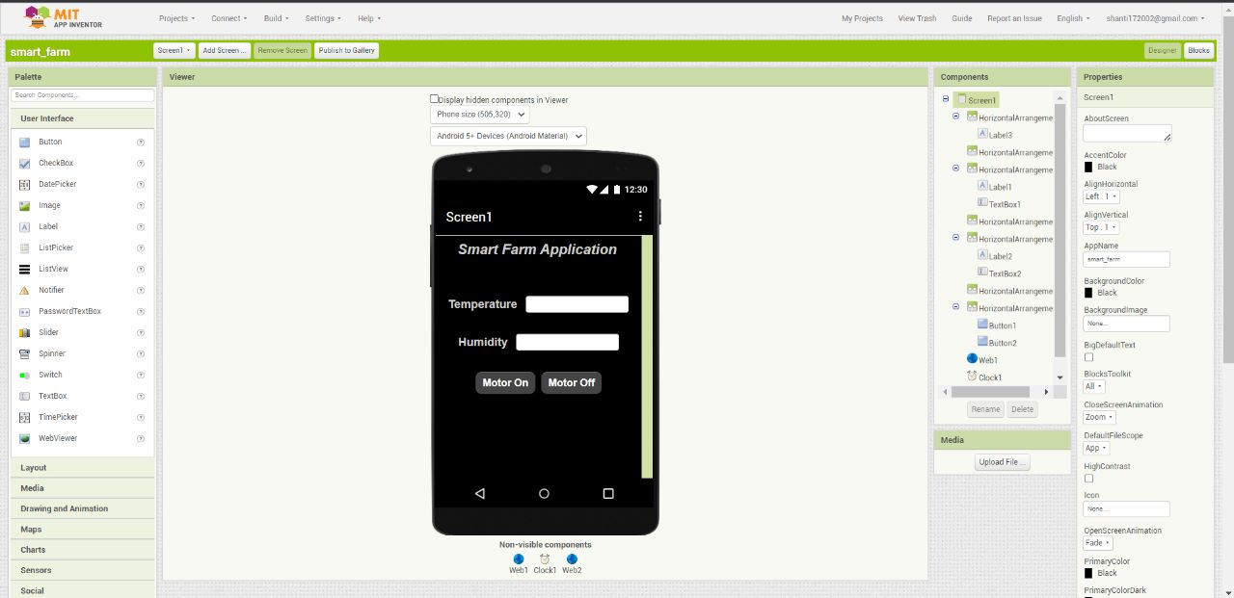

Constructing the Blocks and interfacing into Node-RED

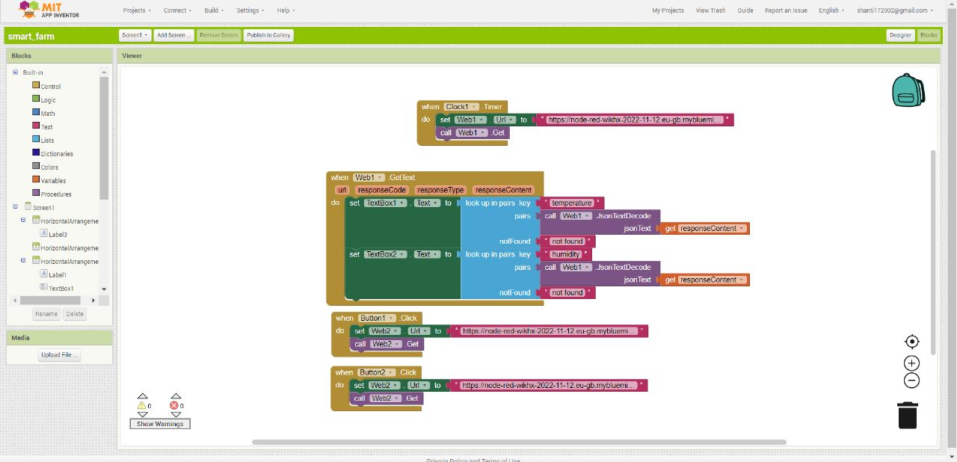

Exporting the Application

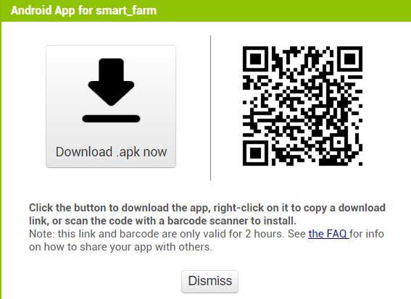

Running the App

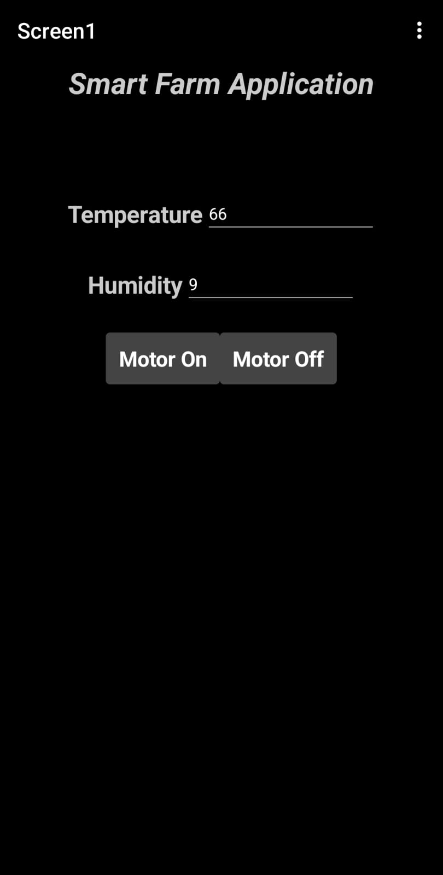

Creating Web UI from Node-RED

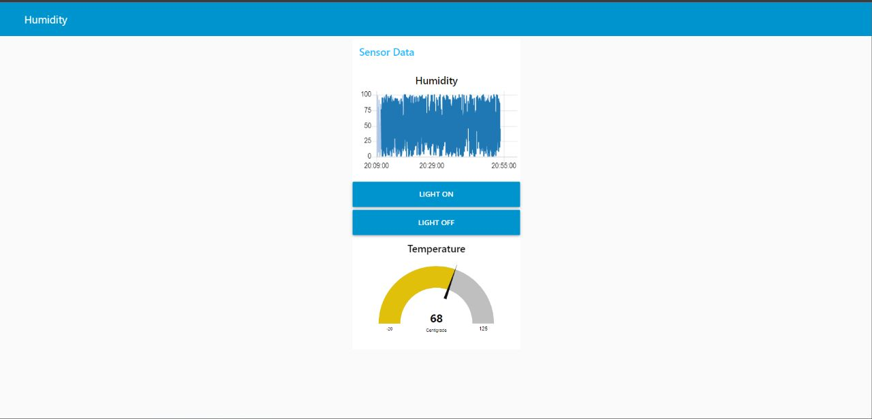

Output for Web UI

